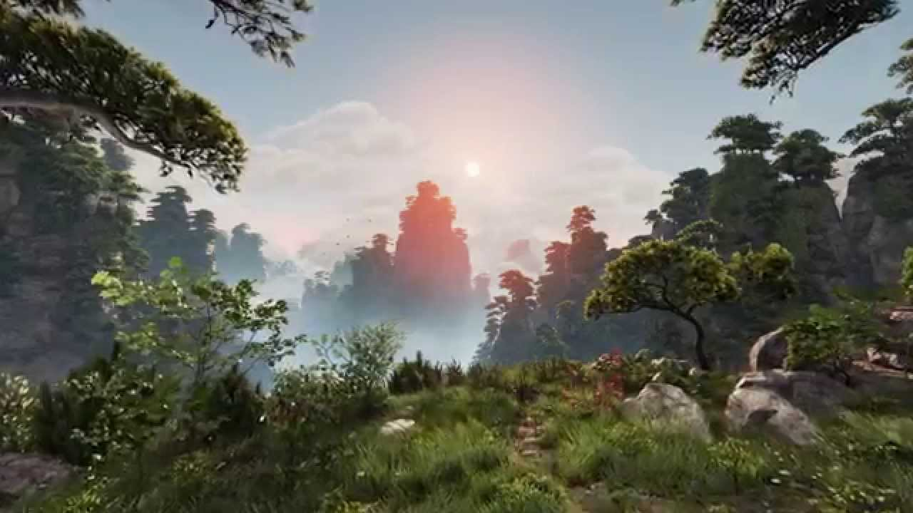
Immersive Storytelling Workshop (“I.S.W”) : Overview: draft 1
This course will empower students, step by step, through the process needed to create dynamic virtual worlds, animated films, and experiences - all through the lens of Virtual Reality.

As a byproduct of this course, students will learn code, optimization, player interaction, and the basic use of Artificial Intelligence. Moreover, they will learn the effective use of storytelling, character development, and how to interject traditional, classic, and proven narrative arcs into the new medium that is VR.

Purpose:
- To empower students with the ability to create fully-realized immersive digital worlds
- To provide students, with transferable skills - that can be applied to multiple software development applications
- To teach students, how to rationalize, approach problems, and creatively break down complex projects into simple, manageable, and achievable tasks.
- Evaluate students’ resumes, with tangible portfolio pieces, geared towards marketplaces of the future.
- To give students a voice of their own

Reason for Existence:
- Students will not be exposed to such material during high school/developmental years
- Students will learn the process of rapid iterative development (crucial for software development)
- To instill students with belief of the fact that they already have the tools, necessary in creating the next generation of storytelling, immersive worlds, and experiences

Operations:
- An afterschool program ran 2x per week
- 6 weeks total = 12 classes
- 2 hour sessions of workshop - 1 hour optional time to work on their “capstone”
- Student Ages 12-18 | Grades 7-12 |

Class Structure:
Each class will vary slightly, depending the lesson, time allotment - but generally speaking, each class will be organized as follows:
- Class ReCap| Show and Tell | Class Lesson/Project | Capstone Project Time | Save and Stretch | Peer Project Free-Play | Q&A | Homework Allotment

Capstone Projects:
Towards the mid-section of the semester, students will be expected to develop their own capstone project. Students will be asked to create a “GDD” a “Game Development Document” - and will be begin the process of development through Greyboxing (Staging), Developing the Dynamics of their System (Coding), Adding Artistic Elements (Art Direction), Optimizing it for playback. All through development, students will be encouraged use “rapid iteration” to alter their projects, based on instructor and peer feedback and playtesting results. After the end of the course, students will showcase their projects to a Gala filled with friends, family and community peers.

Measurable Success of the Immersive Storytelling Workshop Program:
- Number of students who voluntarily join the program each semester
- Percentage of students who regularly attend class
- Capstone Project Completions
- Portfolio pieces obtained

Notes to Tom:

- Tried to squeeze a lot of data on to 1 page - interested in what you would add and/or omit.
- Did not mention any big picture items - such - the ability to empower a fundamental shift of the next generation of students from becoming consumers to content creators - or the potential impact that this program could have on the inner-city youth - those who might not do too hot on tests - but have a knack for the digital arts
- Didn’t mention any big shift items - in terms of how this would affect the thought process of the child - that is - how it would allow them to conceive very complex situations and break them down into manageable - bite size - tasks - such a thought process - can be applied into any field.
- Might want to have a copy editor look at this - I tend to be verbose in my descriptions
- This document, is 1 of 2 in my mind - the other, is harder to define on a single page - but can be regarded as a manifesto for a company I have in mind “childlike” that will combine aspects of this program - but also include the the framework for a fully realized, professional production company
- I love VR and AR - but do not want to limit the program to such - if a student were to complete an animated film using a game engine - that is done in 3d - but shown on a 2d screen - I would count that as a win - as such could be relatively easily adopted for VR. To me, as a maker, I see it all the different fields - as sub-genres :
  - i.e Music Video vs Documentary vs Narrative Short film - in this case - “VR vs AR vs Animated Film vs Hybrid Animated Film (real life footage intermixed in the game engine)
  - What I will not teach is 360 video - I just don’t like it. I will do what I need to do, but I think it’s too easy and a bit lazy.

